Entity design based on database tables

In this document I will present how I have converted all my database tables into C# classes, which later I will use to make the mapping between then and therefore be able to get the data from the database.
To begin this process, I first had to make my database and think out all the requirements for each table, this of course didn’t happen in go as multiple changes to the tables had to be made so that all the desired functionalities could be achieved.
The creation of the entities can be described as simply as just copying and pasting the name, datatype and properties of a table’s fields. Some datatypes tend to differ since they have two different languages and systems, so research on which datatypes matched which had to be made. On each table I will show how I have matched datatypes. I wont mention repeating data matches to avoid repetition, since the logic and sentence will be the exact same
Additionally, each tables inherits an abstract class called “Base”, which contains only a property Id, with the [Key] attribute, so it’s clear it is the primary key. This inheritance of the “Base” class will later be used for in CRUD actions.
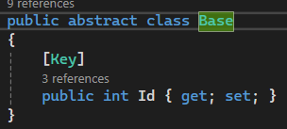

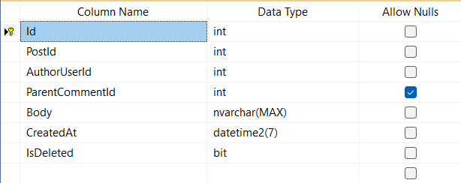
Comment
The comment table has the properties:
- Id – The primary key
- PostId – Foreign key, refencing the post to which
the comment was posted to
- AuthorUserId - Foreign key, refining the user, which
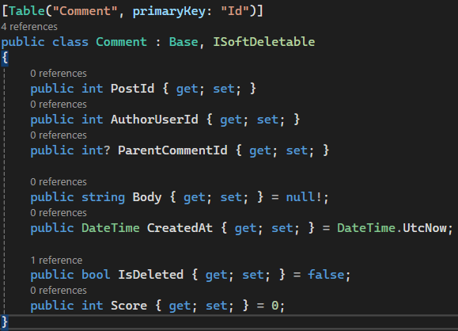
wrote the comment
- ParentCommentId – a property used to reference a
parent comment if this was comment was posted as a
reply to another comment
- Body – the text of the comment
- CreatedAt – when the comment was created
- IsDeleted – a property for soft deleting objects, ones
that are not visible, but still exist in the database

Data matching
Nvarchar represent a list of symbols and it’s the safest way
to map string onto a database
Since sql doesn’t need the use of true and false, the safest
way to map a bool would be to a bit, with 1 being true and 0 false

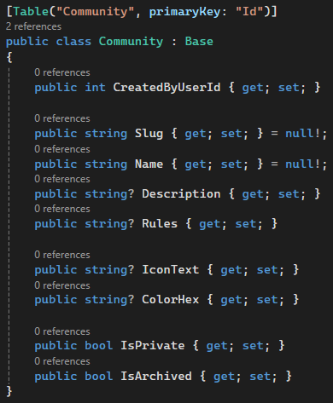
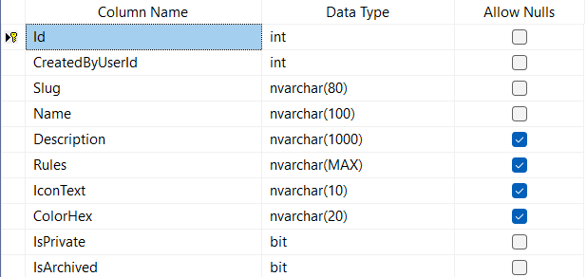
Community
The community tables has the following properties:
- Id - The primary key
- CreatedByUserId – Foreign key referencing the user which
created the guild
- Slug – Unique URL-friendly identifier
- Name – The name of the guild
- Description – short description to inform users what to
expect in the guild
- Rules – Community guidelines
- IconText – short text to fallback incase the icon fails to load
- ColorHex – color code for the guilds styles
- IsPrivate – indicates whether the guilds is private or be
able to be publicly seen
- IsArchived – shows whether the guild accepts new members
and/or posts

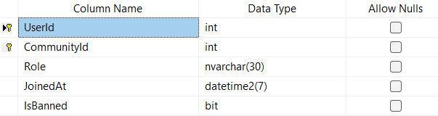
CommunityMember
A bridge table used to show whether a user is a member of a
certain guild, it enables many-many relationship, and uses a
composite key made up of the UserId and CommunityId being
concatenated.

The community tables has the following properties:
- Role – to show what the user can do it this guild, going from member to moderator and administrator
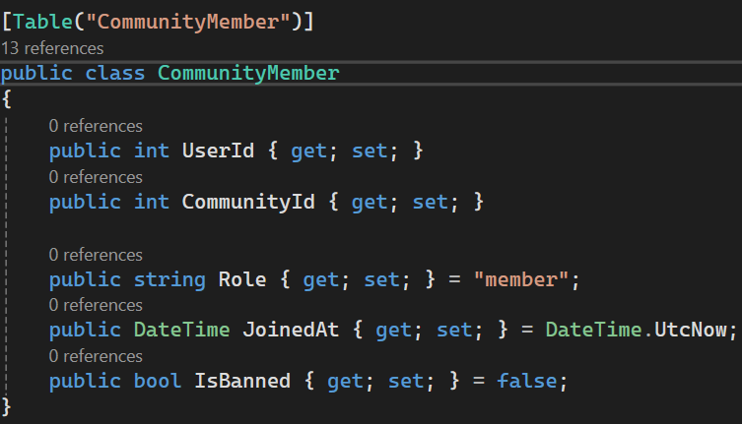
- JoinedAt – shows when the user has joined the guild
- IsBanned – if a user is banned, they will be unable to both
see and join the guild

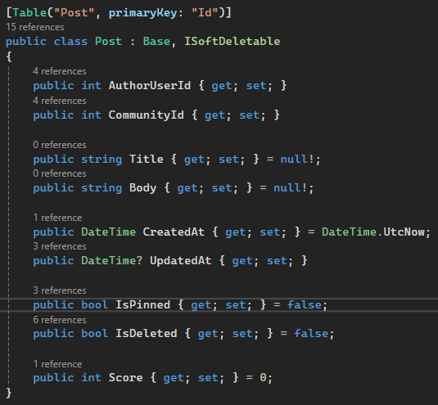
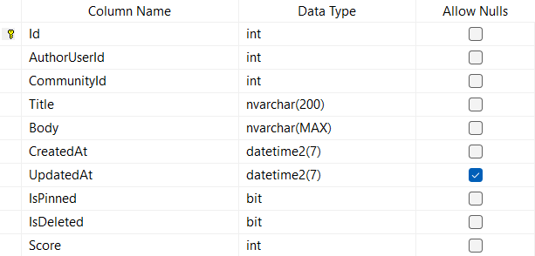
Post
The post table has the following properties:
- Id – The primary key
- AuthorUserId – The author of the post
- CommunityId – The community to which the post belongs to
- Title – The title of the post
- Body – The text which the post contains
- CreatedAt – The date on which the post was created
- UpdatedAt – A Null properties which shows when the post was
updated
- IsPinned – If a post is pinned it will show at the top of the guild
- IsDeled – If this properties is true the post wont show up
- Score – the higher the score, the better the post did

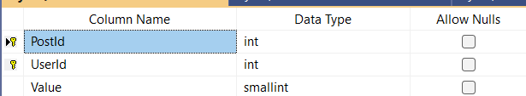
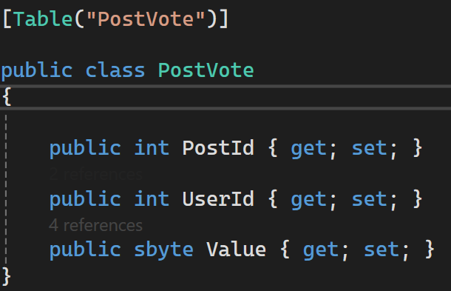
PostVote
The post vote is another bridge table to establish a many-many connection
between users and posts, to show which user has interacted with which
post. The composite key is formed by concatenation of PostId and UserId

This table only has the property Value which shows how much points
the user will give to the posts

Data matching
Since sbyte doesn’t have an exactly matching value in sql, the closes type
we can get to is smallint. Why small int? Because sbyte contains a value
from -127 to 128

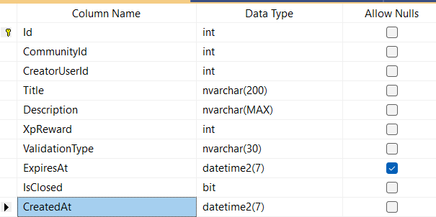
Quests
While this table does have an entity to which it matches, the system in which they are included is not being made, so I will cover it later once I am done with that feature

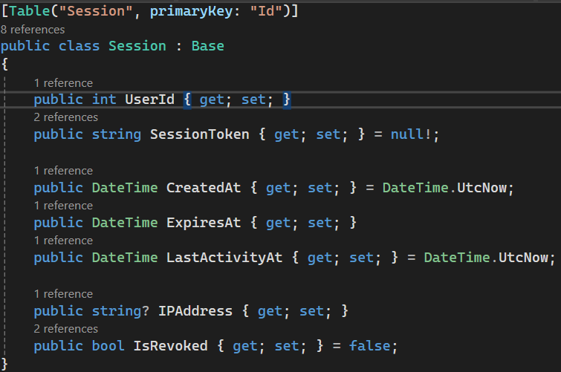
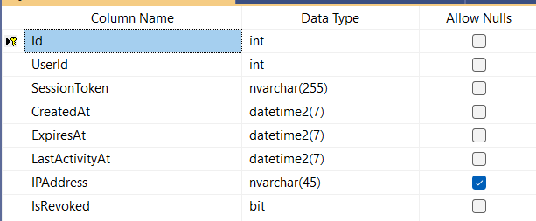
Session
Sessions are key table, used for user authentication, when a user
logs in they receive a unique session token which is valid only for
the current session, after which it gets disabled

The application check for the users IP to make sure the device
is the same as the one in the table and the session token is a
unique string of characters generated on create

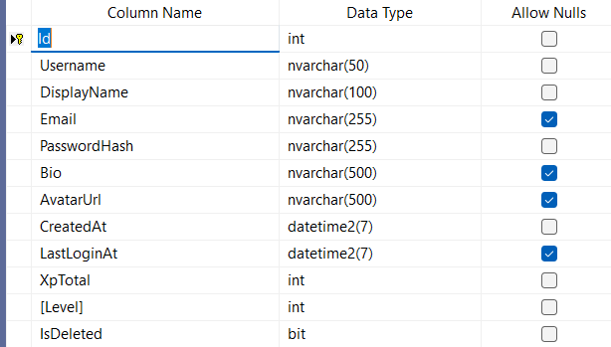
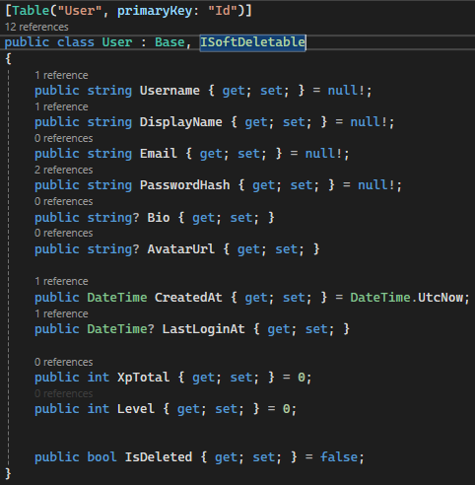
User
This table has the following properties:
- Id – The primary key
- Username – The unique username used for identification
and login
- DisplayName – The name displayed publicly to other users
- Email – The user’s email address used for authentication
- PasswordHash – The hashed version of the user’s password
- Bio – A short description about the user
- AvatarUrl – The URL of the user’s profile image
- CreatedAt – The date the user account was created
- LastLoginAt – The date of the user’s last login
- XpTotal – The total experience points accumulated by the user
- Level – The user’s current level based on experience points
- IsDeleted – If true, the user is soft-deleted and not visible

